Synopsis

Project Title
Automated Credit Risk Categorization for Loan Approval

Problem Id: 8
SAMIKSHA GURUNG
2028836
Section Q

- PROBLEM DESCRIPTION:
The project focuses on automating the process of loan approval using machine learning. Financial institutions often face difficulty in identifying whether an applicant will repay the loan or default. Manual screening is time-consuming and prone to errors.
In this system, we use parameters such as credit score, annual income, and debt-to-income ratio to evaluate the applicant’s financial condition. A machine learning model is trained on past data to classify applicants into two categories: safe or risky.
Since real-world data is often imbalanced, techniques like SMOTE are used to balance the dataset. Logistic Regression is applied to make predictions, and evaluation metrics such as precision and F1-score are used to measure performance.
This system helps banks make faster, more accurate, and automated loan approval decisions while minimizing financial risks.

- STEPS OF IMPLEMENTATION:

- Data Collection (create or download dataset)
- Data Preprocessing (clean and organize data)
- Data Balancing (using SMOTE to handle imbalance)
- Model Training (using Logistic Regression)
- Model Evaluation (Precision, F1-score)
- Prediction (classify new applicants)

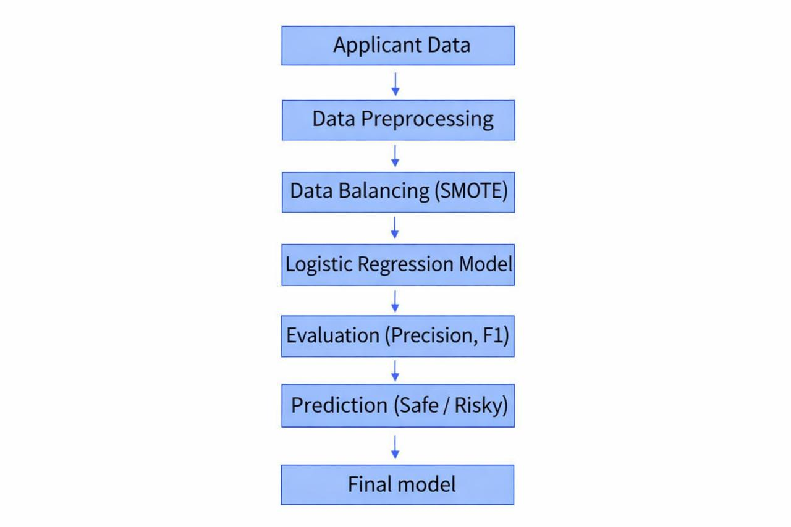
Fig 1.Sample architecture

- EXPECTED MODULES/ LIBRARIES TO BE USED :
pandas → for data handling (dataset loading, cleaning)
numpy → for numerical operations
sklearn.preprocessing → for data preprocessing (scaling + encoding)
sklearn.model_selection → for train-test split
sklearn.linear_model → for Logistic Regression model
sklearn.metrics → for evaluation (accuracy, confusion matrix)
imblearn.over_sampling (SMOTE) → for handling imbalanced data

- EXPECTED EVALUATION METRICS AND PLOTS TO BE USED:
Precision – measures correctness of risky predictions
F1-score – balances precision and recall
Confusion Matrix – shows correct vs incorrect predictions

- REQUIRED TOPICS FROM THE SUBJECT:

1. Data Preprocessing
- Handling missing values (fillna())
- Encoding categorical data
- Label Encoding (Male/Female → 0/1)
- Feature Scaling
- Standardization using StandardScaler

2. Exploratory Data Analysis (EDA)
- Understanding dataset
- Checking:
- Mean, median, distribution
- Class imbalance (Default vs Non-default)

3. Train-Test Split
- Splitting data into:
- Training (80%)
- Testing (20%)

4. Imbalanced Data Handling
- Problem: Very few “Default” cases
- Solution: SMOTE (Oversampling)

5. Logistic Regression (CORE MODEL)
- Used for classification (Yes/No → Default or Not)
- Works on probability (0 to 1)

6. Model Evaluation
- Accuracy Score
- Confusion Matrix:
- True Positive, False Positive etc.

7. Feature Selection
- Input features:
- Credit Score
- Income
- Debt-to-Income Ratio

- PLATFORM REQUIRED:
Visual studio/ jupyter notebook/ python idle.

- BOOKS AND LINK SOURCES:
Let Us Python~Yahwant Kanetkar
Hands-On Machine Learning with Scikit-Learn, Keras, and TensorFlow ~ Aurélien Géron
Claude
https://claude.ai
www.youtube.in

